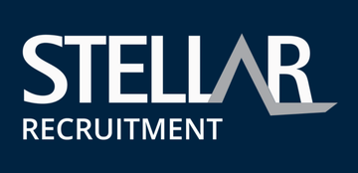
Field Supervisor
Stellar Recruitment
View all jobs
Cairns, Cairns & Far North QLD
Mining - Exploration & Geoscience (Mining, Resources & Energy)
Full time
Competitive Salary + Employee Share Option Plan
Posted 10d ago
About the Opportunity
An exciting opportunity exists for a Field / Project Supervisor to join an ASX listed copper exploration company operating in the Mt Isa / Cloncurry region. This role is suited to a practical, delivery-focused supervisor who enjoys working in lean teams and being actively involved in site operations.
The position will see you overseeing small field crews while remaining hands-on across day-to-day activities including, exploration drilling and exploration programs, logistics and some environmental monitoring. Accommodation is available and FIFO can be considered from Cairns, Townsville, Mackay or Brisbane, or DIDO from Mount Isa.
A start date of February / March is preferred to align with a ramp up in activity.
Key Responsibilities
- Supervise and support a small team of field technicians (typically 1–5 personnel)
- Actively participate in field work as required to support exploration programs.
- Coordinate logistics for field activities, mobilisation and site operations.
- Undertake and oversee environmental monitoring, including pumps, bore monitoring and water balance awareness.
- Ensure all site activities are conducted safely and in line with regulatory and company requirements.
- Liaise with technical and management teams to ensure smooth delivery of exploration works.
Benefits
- Potential employee share option plan might be available down the track.
- FIFO from Cairns, Townsville, Mackay or Brisbane, DIDO from Mount Isa, or Cloncurry residential option
- Nominal 2:1/8:6 roster with flights paid for by the client.
- Opportunity to join a business at a pivotal growth stage.
- Permanent position
Requirements
- Previous experience supervising small teams in exploration programs.
- Strong hands-on capability and willingness to work alongside the crew.
- Experience working within small or growing organisations with a preference for mining exploration companies being preferred.
- Strong organisational and logistical coordination skills
- Ability to work autonomously in remote locations.
If you are looking for a practical supervisory role with genuine responsibility and long-term opportunity, click Apply Now.

